Available online @ https://jjem.jnnce.ac.in
https:www.doi.org/10.37314/JJEM.xxxx.xxxxxx
Indexed in International Scientific Indiexing (ISI)
Impact factor: 1.395 for 2021-22
Published on: xxxxxxxxxxxx

Preparation of Paper for JNNCE Journal of Engineering and Management

First author¹*, Second author², Third author³

^{1*}Affiliation of first author, ²Affiliation of second author
³Affiliation of third author

Email id of first author, Email id of second author, Email id of third author

Abstract

Abstract serves as a substitute for your entire work. It should contain in brief, main motivation, main design point, essential difference from previous work, methodology, and some eye-catching results if any. The title of the paper must be Times New Roman 16 font size, centered and bold. Abstract heading shall be in Times New Roman, 12 font size bold and italic. The contents of the abstract shall be in Times New Roman 10 font size and italic. Do not use all capital letter for the title. Use one line spacing of 12 font size between the title and the author’s names. Use one line spacing of font 10 between the authors and their affiliations. Use one line spacing of font size 10 between the affiliations and email ids of the authors, between email ids and abstract heading and between abstract heading and abstract. Do not cite any references in the abstract and minimum 3 key words are to be given. The heading keywords shall be bold and both heading and keywords shall be in italic. The contents of the abstract must be justified. Corresponding author shall have an asterisk mark as superscript as shown in this sample.

Keywords: Retinopathy, Segmentation, Image Processing

- Introduction

Use Arabic numbering system in sequence for main headings. The paper shall be prepared in letter size 8.5” x 11”. The body of the paper must be in two columns each of width 3.16” and spacing between the columns shall be 0.17”. Use Times New Roman of 12 font size for the text. The contents in each column must be justified and ensure that no words shall be cut with a hyphen between one line to other line. All figures shall have caption at the bottom (see the figure in this sample) and all tables shall have caption at the top. All references, figures and tables must be cited in the text. Equations shall be generated using equation editor and must have number in sequence. All headings shall be in sentence case with first letter of each word capital, bold and left aligned.
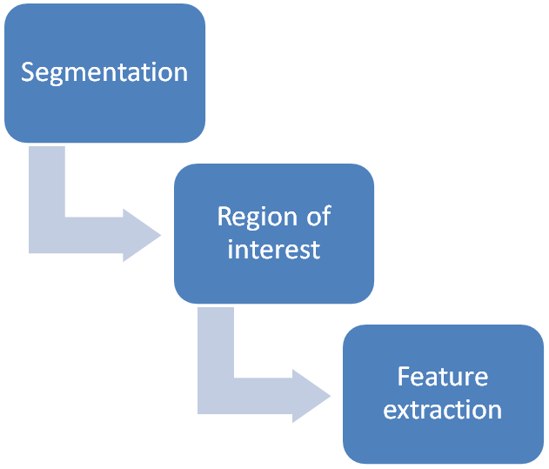

Figure 1: Flow Diagram of Proposed system

If the figure/flowcharts/tables are very big in size and are difficult/impossible to accommodate in a column of double-column

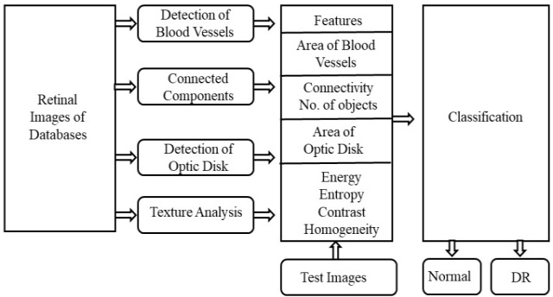

Figure 2: Block diagram of proposed methodology

paper, such figures can be put one column page (only for that portion of the figure/table) centered and preferably shall be either at the top or at the bottom of the page. See figure number 2 in this sample. Each paper published in JJEM will have a unique doi number. The authors can visit our site http://jjem.jnnce.ac.in/ for the details of the journal.

Authors are informed to include a brief review of the literature as a part of introduction and not as a separate title. Use et al. for more than two authors. No initials are to be used for author names. Ex. Hosur et al [1] carried out experimental investigation on …….. , where number in the square bracket is the reference number for the paper discussed. Rather than literally copying the texts that you have read, you should present your own interpretation of the theory. This will help you in developing your own thinking discipline and technical language.

  - Paper Submission

All sub headings must be of font 12 and bold and left aligned. Use sub headings up to the order of two ex. 1.1.1 and avoid using subheadings of order 3 such as 1.1.1.1. Please submit your papers (MS-Word file) through http://jjem.jnnce.ac.in/submission.html
Authors are invited to submit papers for JJEM through Email:submit_jjem@jnnce.ac.in Submissions must be original and should not have been published previously or be under consideration for publication while being evaluated for this journal. Authors are requested to provide full details for correspondence: postal address, phone numbers and email address. Authors are requested to prepare their soft copy version only in Word formats (.docx, .doc) and not in PDF version.

    - Review Process

Submissions are accepted for review with the understanding that the same work has been neither submitted to, nor published in, another publication. Simultaneous submission to other publications will result in immediate rejection of the paper. Papers are not within the journal scope will be rejected immediately after the pre review process.

All manuscripts will be subject to a well established, fair, unbiased peer review and refereeing procedure, and are considered on the basis of their significance, novelty and usefulness to the Journals readership. The reviewing structure will always ensure the anonymity of the referees & it will be reviewed by experts in the field. The review process may take approximately two ~ three months to be completed. The Editor reserves the right to reject a paper if it does not meet the aims and scope of the journal, it is not revised well.
All accepted papers for publication will be have to meet international standards of written English. Authors must swiftly respond to all communications during the publication process.

- Main Text

This section is more work specific. Describe the methodology used to carry out the investigation. Write a clear, informative, and thoughtful description and critique of what you did. Where appropriate, include carefully drawn graphs, diagrams and tables. Include discussion of your results. Analyze and interpret your data, and discuss the significance and limitations of your findings. Discuss whether your results support or contradict the existing results and give most plausible explanations of your findings. Clearly state the final conclusions about the significance of the results relative to the planning.

References

Arrange alphabetically with single spaces. For an article of a journal: name of the authors, title, name of the journal, volume no, issue no, year and range of pages. If the article has doi, mention it after the page number. See reference number 1.

For a book: name of the authors, title, publisher, city of publication, edition and year of publication. See reference number 2.
For a web-site: Author or Organization, name of the site, complete address of the site, date visited. See reference number 3.
Do not write browser name directly like www.google.com, www.youtube.com etc.,

- B.J.Gireesha, G.Sowmya, M.Nikitha, Numerical Investigation of Natural Convection and Radiation In a Moving Radial Porous Fin, JNNCE Journal of Engineering & Management, Vol.4, No.1, 2020, 1-7, https:www.doi.org/10.37314/JJEM.2020.040101

- Taylor J. R., An Introduction to Error Analysis, Oxford University Press, Mill Valley, CA, USA, 3rd Edition 1982

- Danish Wind Industry Association, Aerodynamics of Wind Turbines: Lift, http://www.windpower.org/tour/wtrb/lift.htm, Aug 16, 2002

